PERSONAL IDENTITY SYSTEM · 2026
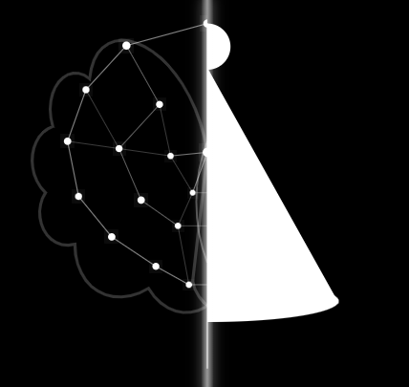 | Moeketsi Fekefeke  43541283 CMPG214-VC-2026SEM1-(CMPG214)  Customer Service Represntative  Bridging logic and culture. I build systems that think.  GitHub Profile: https://github.com/FekSta

WHY THE MARK LOOKS THIS WAY

◑  SPLIT IDENTITY  Left: neural networks — the logic mind | │  THE SEAM  Division & unity. Two halves, one self | ◭  Basotho HAT  Culture, intuition, the other hemisphere

WHAT I CARE ABOUT

DSA  Algorithms define thought  (Bellman-Ford & Dijstra’s Algorithms) | NETWORKING  Distributed Systems and Culture connect worlds | CULTURE  Roots Identity beyond the screen

Reflection

What was hardest to decide?
Choosing one symbol for the split in me between the technical and the cultural, since I could not choose between the two.Every version felt either too clean or too abstract. The seam only worked when I stopped trying to resolve the tension and let it be visible.

What did you remove?
Colour, labels, and ornamentation. An earlier version had text nnotations inside the mark. Removing them made the silence between the halves louder.

What does this design say about you?
The design shows my interest in computer and cultural networking.

